Pharmacist Support
Listening Friends Volunteer
Recruitment Pack
October 2021

Who we are
An independent, trusted charity, we provide a wide variety of support services to pharmacists and their families, former pharmacists and pharmacy students. We’ve listened carefully to people from all sectors of the profession, and deeply understand and empathise with the issues affecting pharmacy today. In our 2019 market research 97% of all potential service users surveyed felt they needed some form of support from the charity with 71% of all respondents citing mental health as a key issue affecting the sector. ​
We believe in better. We listen, without judgement, and encourage and empower people to create positive change. Each year we provide thousands of acts of support – we make good things happen.​
Our connection to the profession is deep. Established by the Royal Pharmaceutical Society of Great Britain (RPSGB) in 1841, the organisation has grown from its Benevolent Fund roots into an independent modern-day charity.​
​We’re proud to be able to support people from such a caring profession, and we’ll never give up on what we like to call our pharmacy ‘family’.​
We launched an exciting new five-year strategy in January 2020 with a new vision and mission and redefined values.
Our Vision
No one in our pharmacy family will face challenging times without us by their side.

Our Mission
To champion the wellbeing of our pharmacy family

Volunteering for us
Wellbeing is embedded into everyday activities throughout Pharmacist Support. Our services put people first, create positive impact and deliver on our aspiration as a charity for an empowered and resilient pharmacy workforce. As a charity, our values are very important to us and guide the way we work.

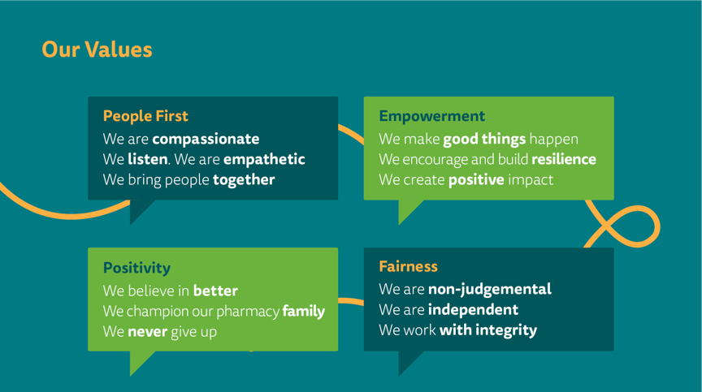

About the Listening Friends Peer Support Service

The Listening Friends service was established 25 years ago and provides confidential peer support over the telephone for pharmacists at any stage in their pharmacy career.
This service offers callers an opportunity to speak in confidence to one the schemes trained volunteer pharmacists about the stresses or pressures working in or studying pharmacy may be causing them. Volunteers do not provide advice, but they recognise the pressures of pharmacy practice and will offer the time and space to talk through those issues to try to find clarity. They can also sign post to other organisations who can provide further specialised help and support.
What we are looking for
We’re currently looking to recruit volunteers to our Listening Friends scheme.
The past 18 months have been incredibly difficult for the sector and here at Pharmacist Support we’re keen to ensure no one in our pharmacy family has to face challenging times without us by their side. We are committed to promoting equality, valuing diversity, and creating an inclusive environment and welcome interest from individuals of all ages, backgrounds, cultures, and levels of experience. If you have a passion for the helping others and feel that you can offer up to a couple of hours a week of your time to talk to a fellow member of our pharmacy family in need of support, we would like to hear from you.

Support and training

As one of our volunteers we provide you with both initial and ongoing training and opportunities to connect with other Listening Friends to support you in this important role.

Listening Friends volunteers conduct their support calls from home and are provided with a code to withhold their number and charge the cost of the call back to the charity.

Skills, experience and qualities
- Past or present experience of working as a pharmacist
- Ability to listen and empathise with clients.
- Excellent communication and interpersonal skills.
- Awareness of current concerns and issues affecting the profession.
- Ability to provide non-judgmental and impartial support.
- Commitment to personal development and training.
- Access to the internet, email and a secure personal mobile phone.
- Good level of IT skills
- Willingness to support us in demonstrating our values.
Key accountabilities:
- To represent Pharmacist Support in a caring and professional manner.
- To listen to the concerns of the client and support them to find their own solutions.
- To develop and maintain a supportive relationship with people requiring peer support from someone who understands the pressures of the profession.
- To signpost clients where appropriate as directed by Pharmacist Support.
- To provide data to allow the charity to monitor the service by completing the volunteer call log on completion of each call.
- To work within Pharmacist Support guidelines, adhering to confidentiality, safeguarding and all other applicable policies/procedures.

The Recruitment Process

To apply for a Listening Friends volunteer role, we ask that you complete the application form and return it to volunteers@pharmacistsupport.org by 5pm 22nd October 2021.
Diversity monitoring
To help us ensure we are adhering to our diversity policy we ask that you complete the equal opportunities monitoring form. This enables us to monitor the diversity profile of people who apply for Pharmacist Support posts. This information is given in confidence for monitoring purposes only and is not seen by anyone responsible for making recruitment decisions. However, if you would prefer not to answer any of the questions we ask, please leave them blank.

Shortlisting & interviews
Successful candidates will be invited to interview which will take place early November via zoom.

References
It is Pharmacist Support policy to take up written references for potential volunteers before they start. Please provide two referees from people who have known you reasonably well for over two years. These should not, if possible, be close friends or anyone directly related to you.

